Linux

Task 1-13
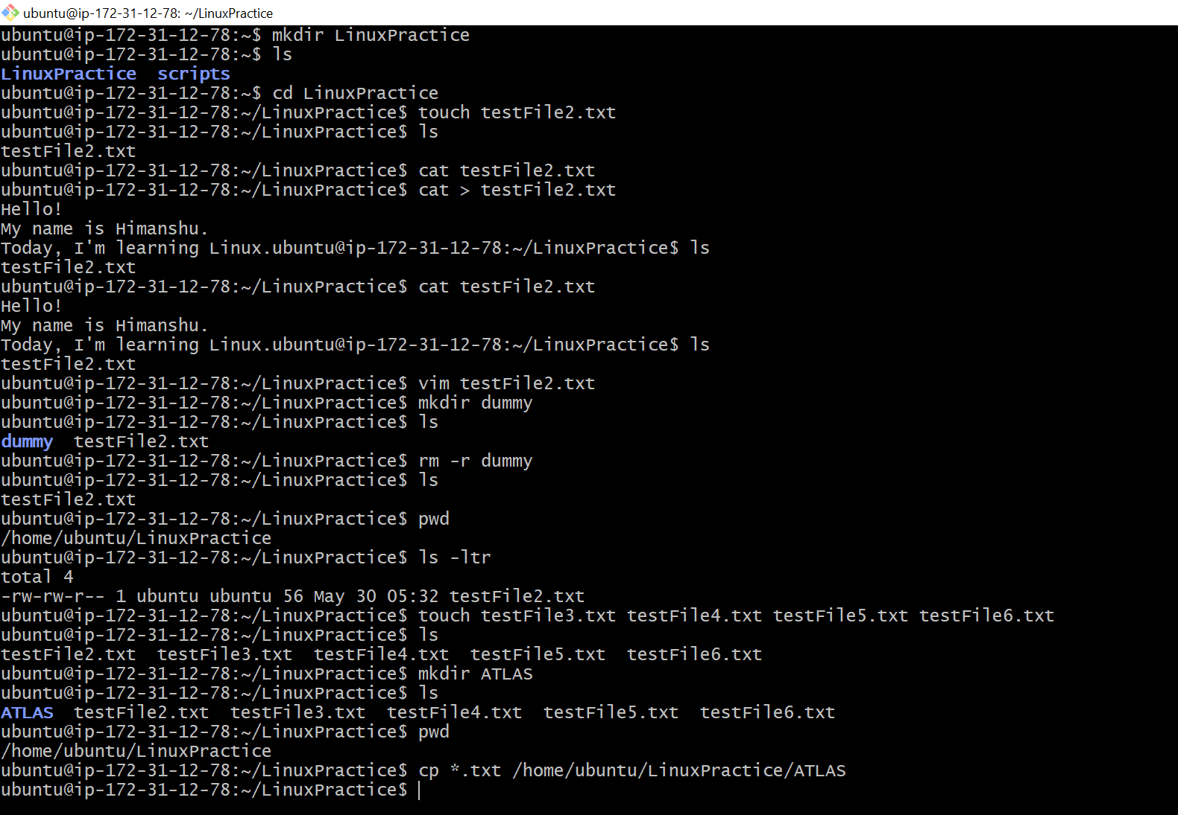

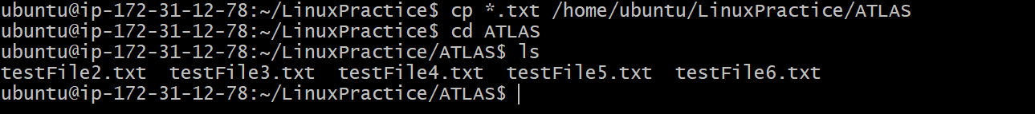

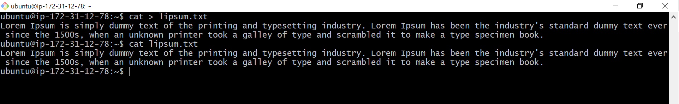

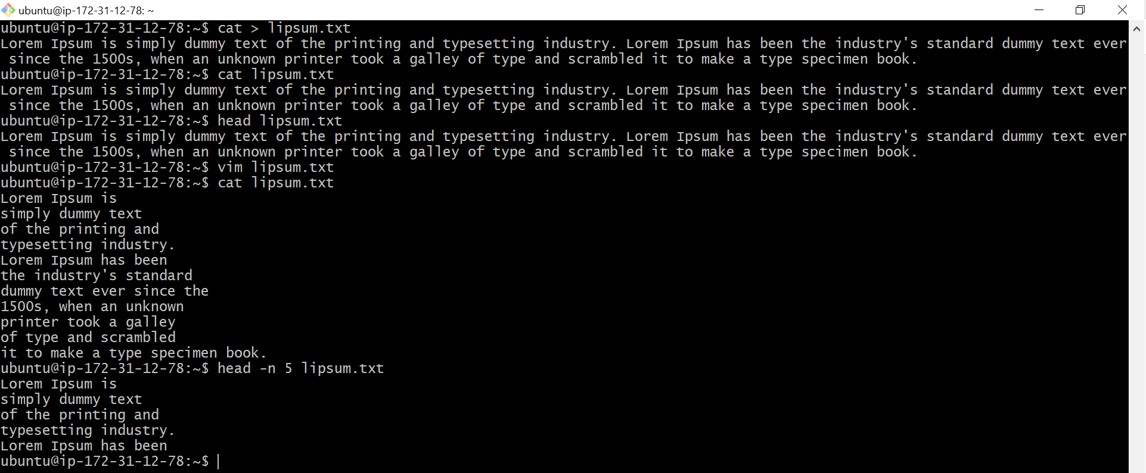

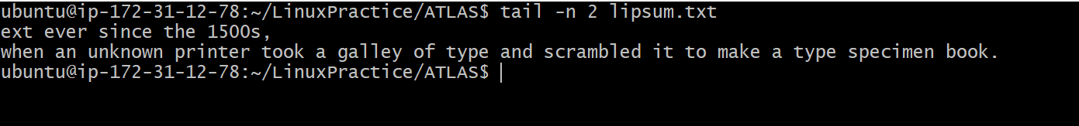

Task 14

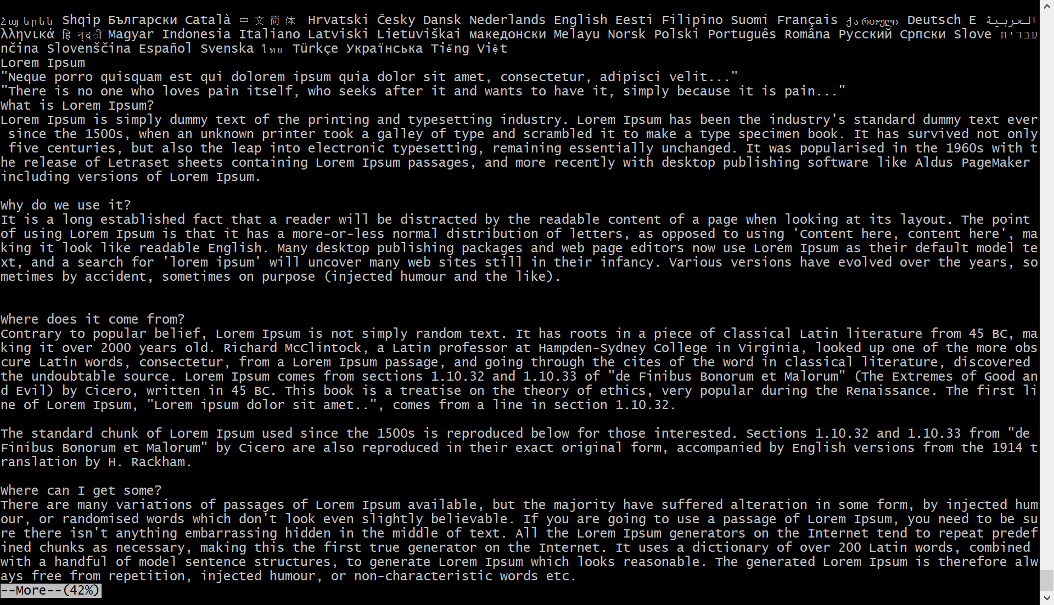

Task: 15

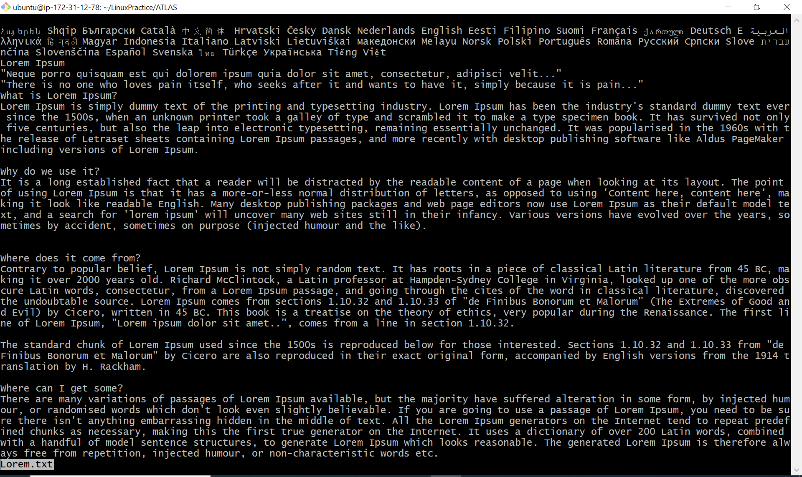

Task 16:

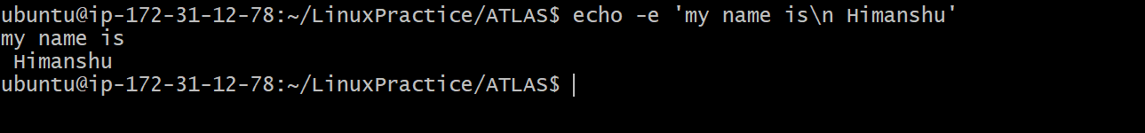

Task 17:

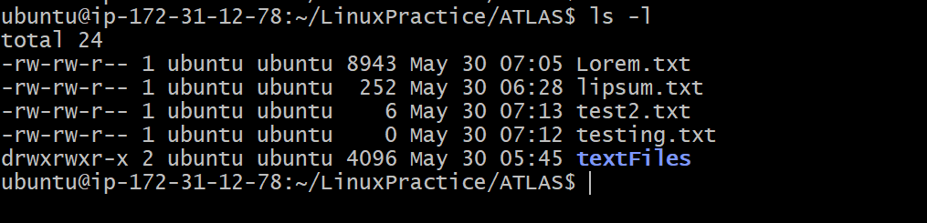
Task 18:

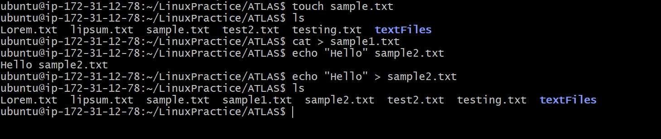

Touch command: this command will create a file without asking to enter text.
Cat command: with contact we can create files and also we can contact files
Echo command: this command enables the user to enter the text in double quotes and redirect it to the file.

Task 19:
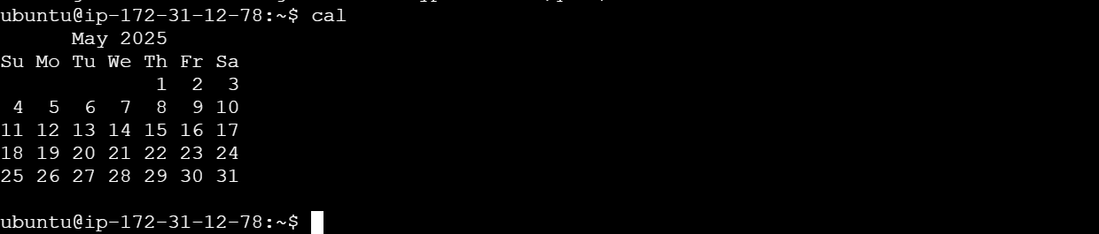

Task 20:

Task 21:

Task 22:

Task 23:
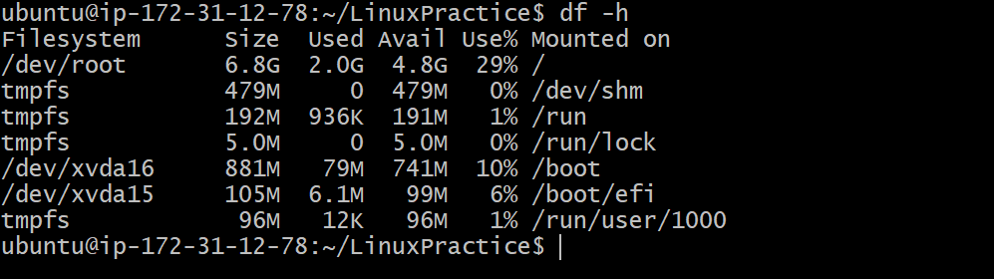

Task 25:

Task 26:

Task 27:
. Represent current directory
.. Represents parent directory

Task 28:
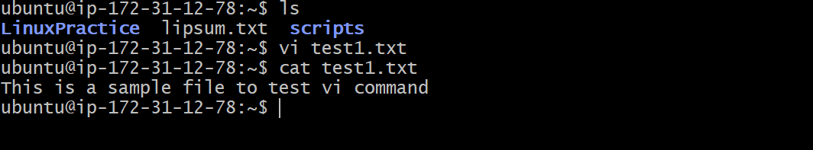

Task 29:
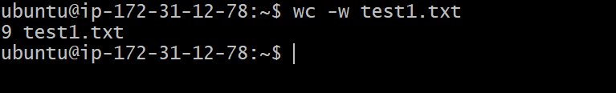

Task 30:

cat -b test1.txt : this command will give the output line by line with numbered format.

Task 31:
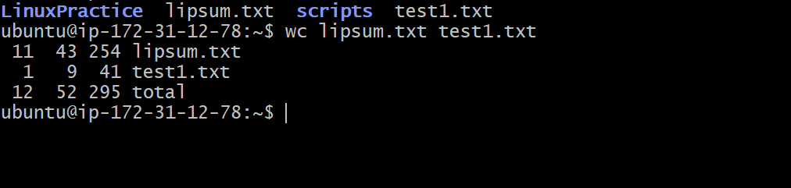

Task 32:

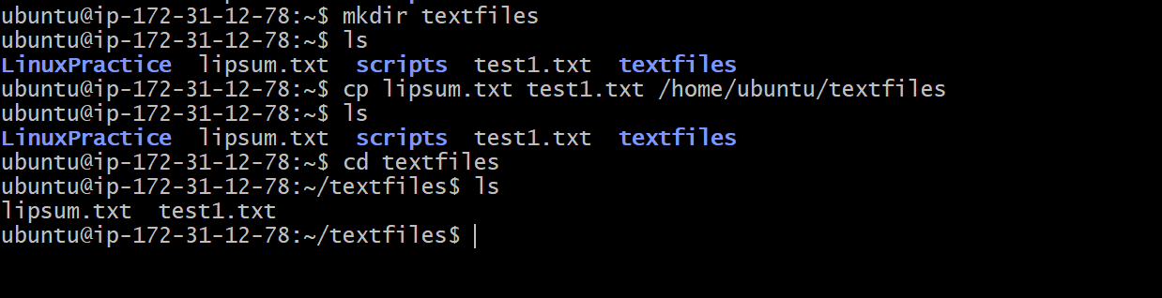

Task 33:
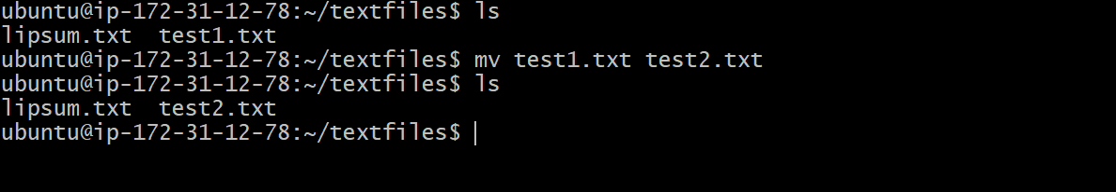

Task 34:
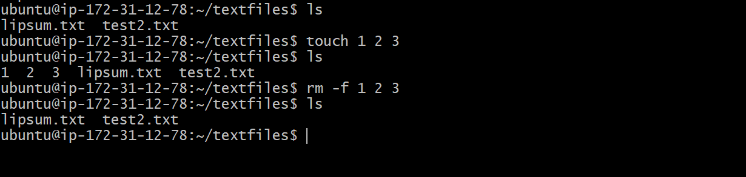
Task 35:
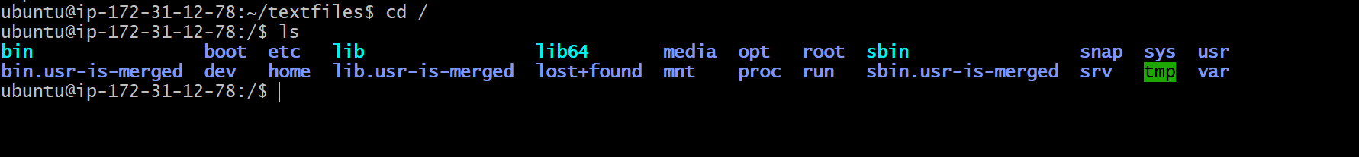

Task 36:
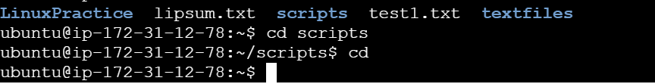

Task 37:

